**Author.html:**

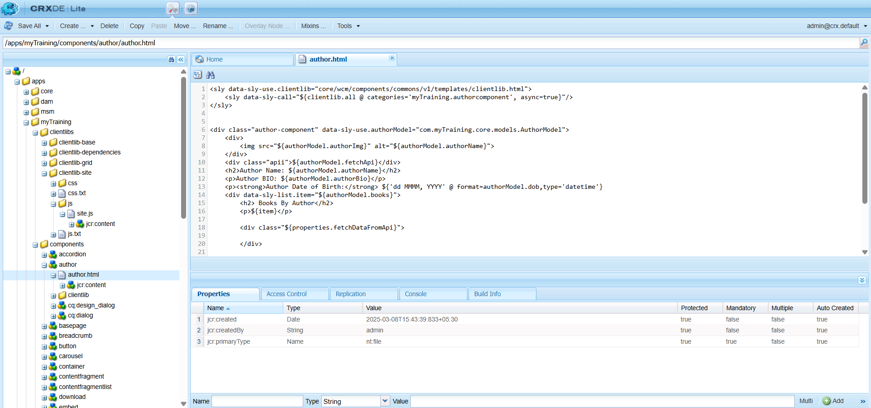

**site.js in the client libs folder to retrieve data from an API URL:**

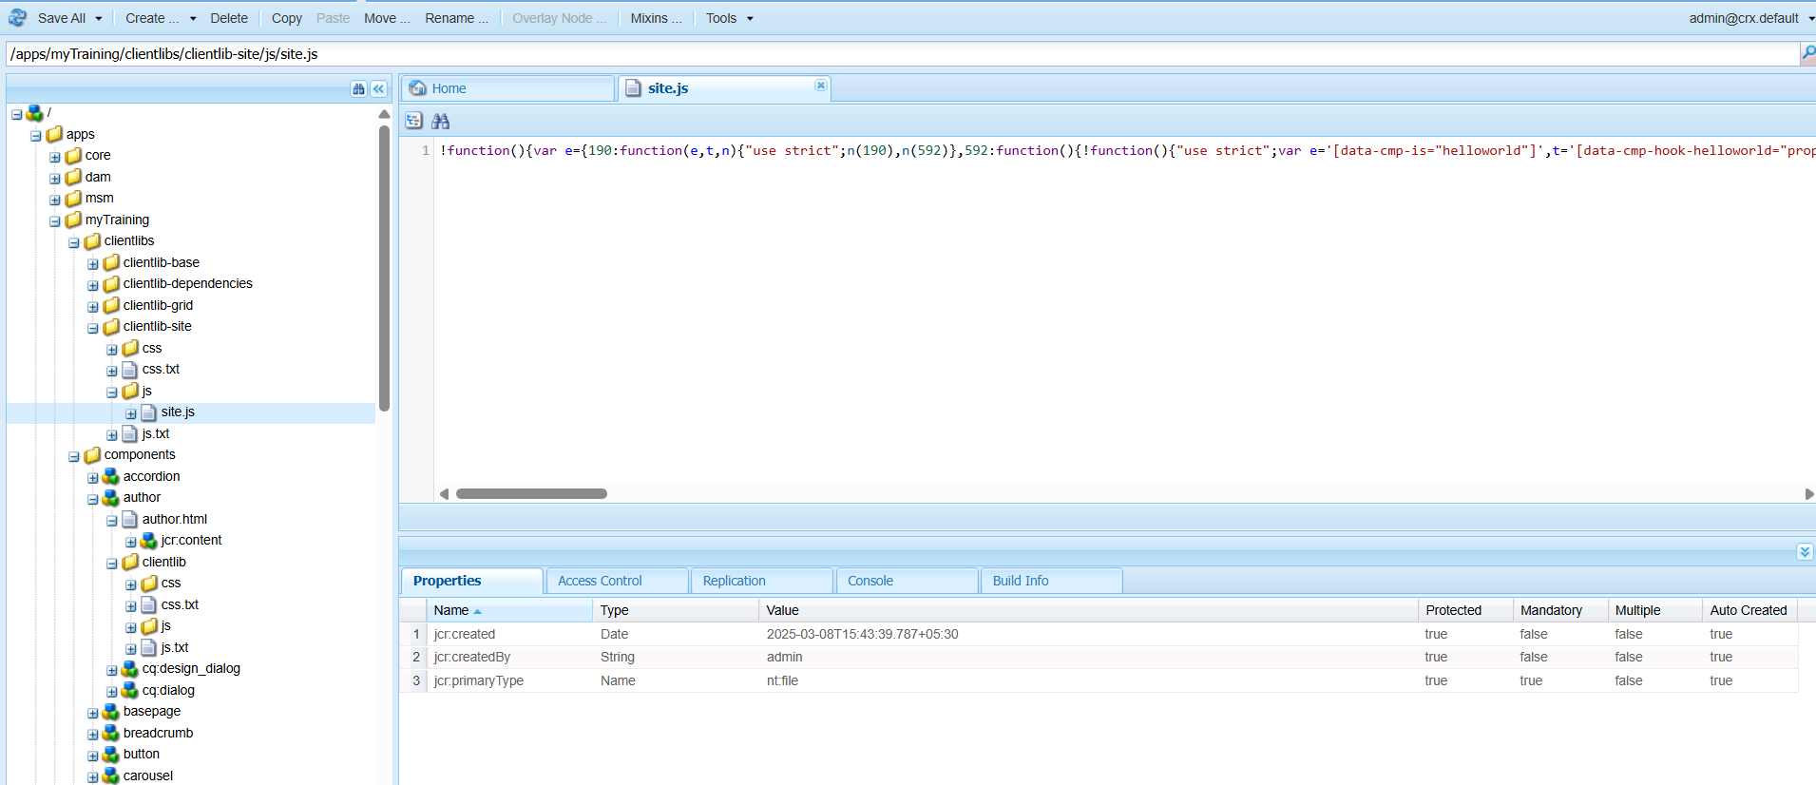

**Component :**  
Calls the Sling Model to display book details in cards (Name, Image, Description, Publish Date).

**Author component includes details such as the author's name, date of birth, and a checkbox to enable data fetching via API.**

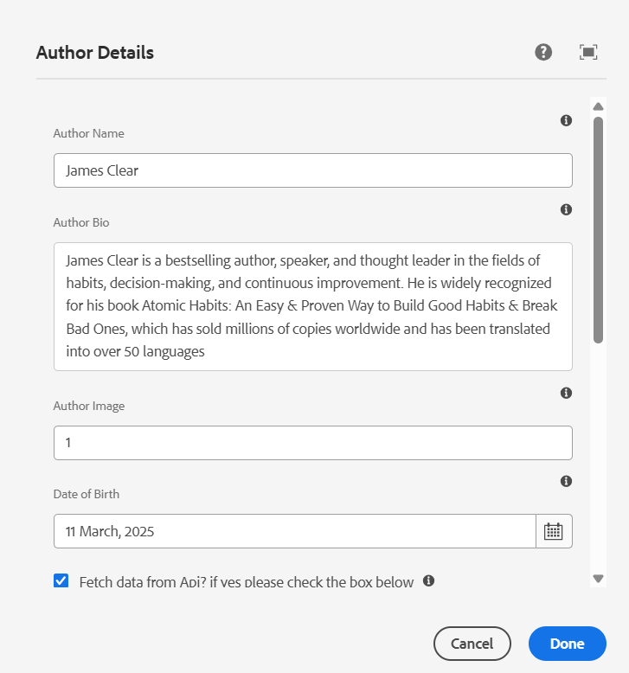

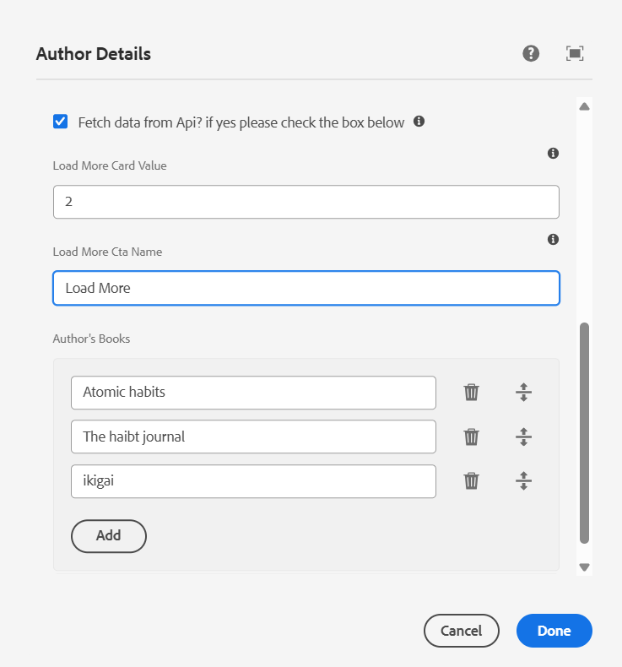

**The author card displays details:**

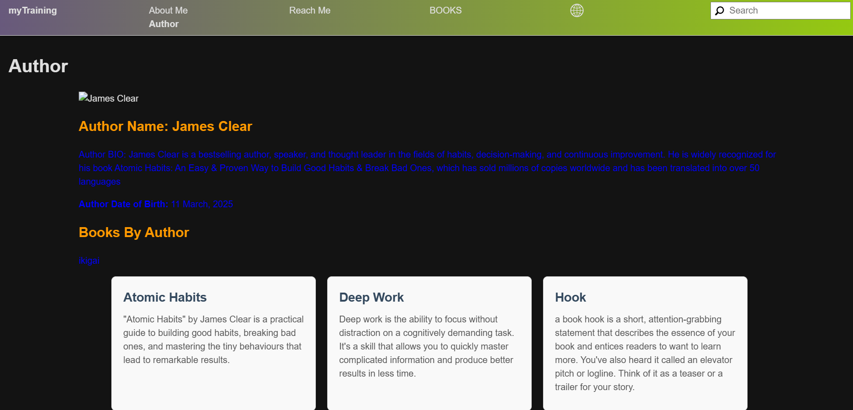

**Displays all books of an author in card format with a "Load More" button. Supports horizontal and vertical views using Style System.**

**Before clicking Load More..:**

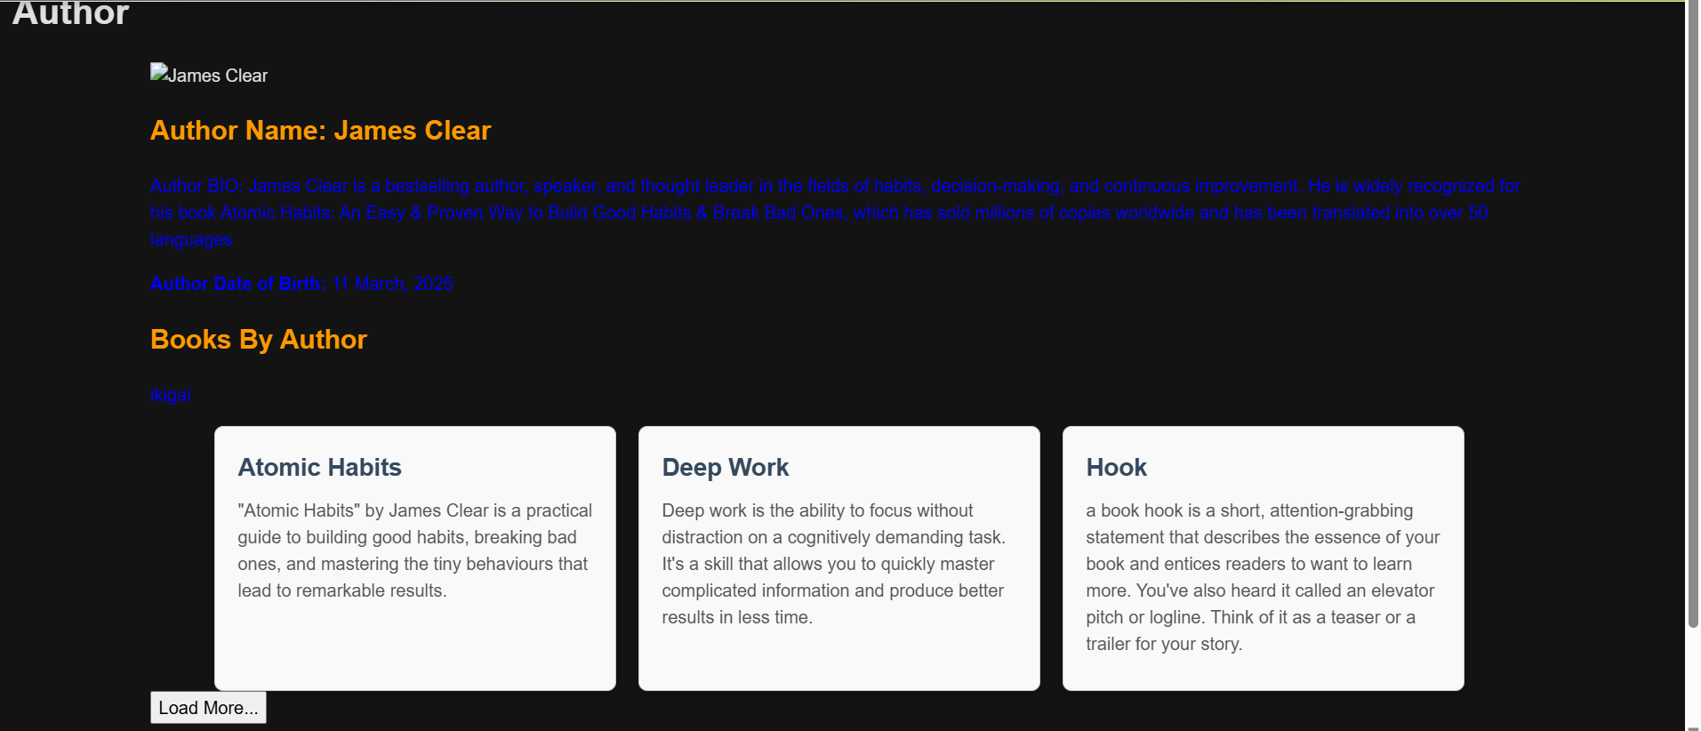

**After clicking Load More:**

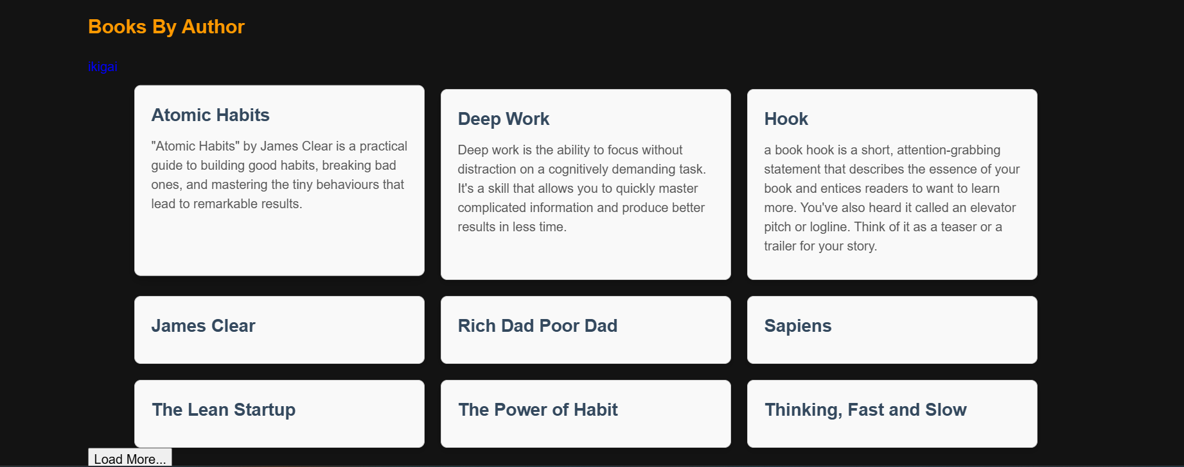

**The Site.js file has been updated to retrieve details from the API:**

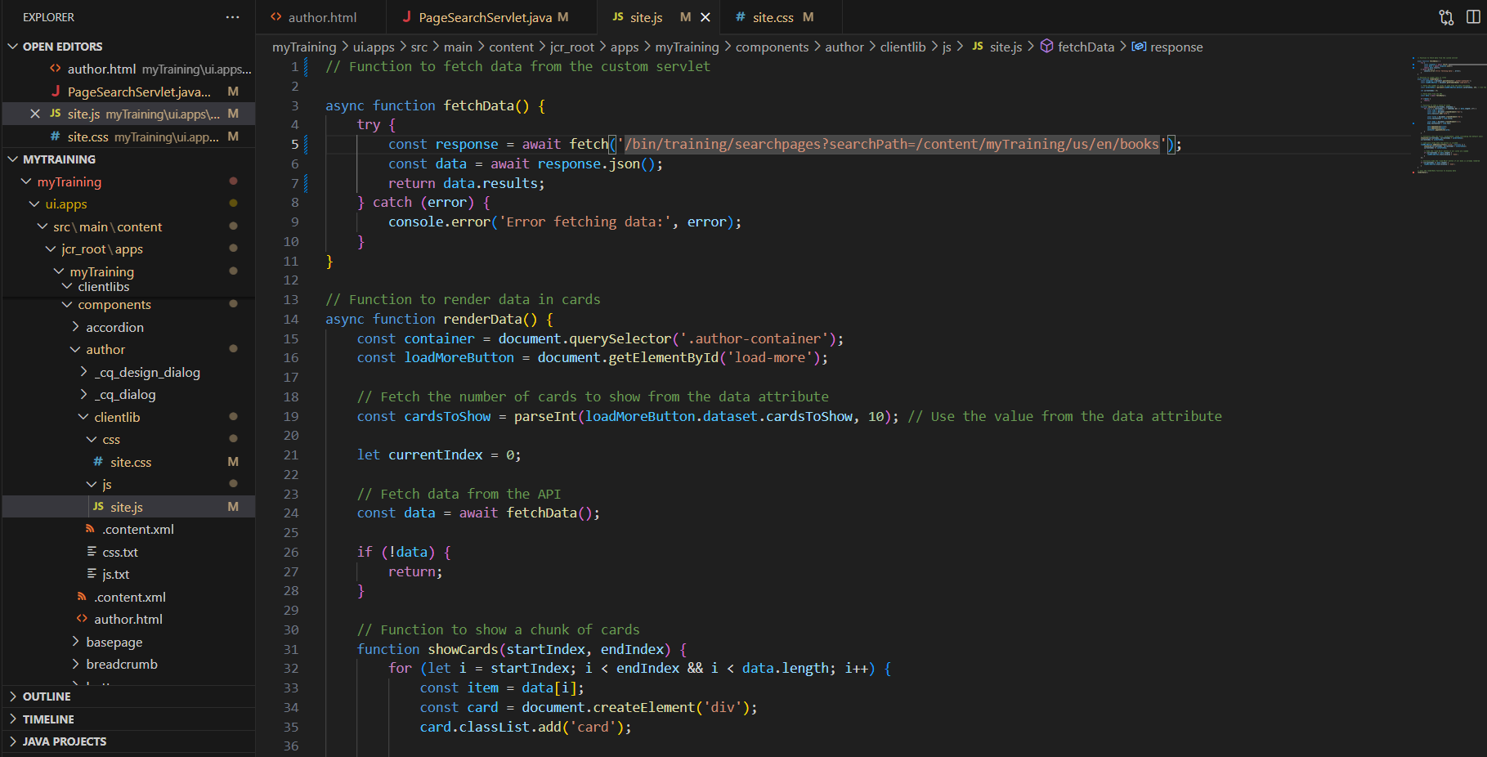

**PageSearchServlet:**

